Fibre reinforced polymer and steel rebar comparative performance.

Richardson A – Senior Lecturer – School of the Built and Natural Environment at Northumbria University , Newcastle upon Tyne, UK. <alan.richardson@unn.ac.uk>

Drew P – Assistant Researcher – School of the Built and Natural Environment at Northumbria University, Newcastle upon Tyne, UK. <paula.drew@unn.ac.uk>

Abstract

Purpose This research investigated the necessary requirements that a concrete reinforcement material must satisfy; namely the ability to resist tensile forces and have good bond strength, whilst providing structural qualities of toughness and flexural strength.

Methodology The bond and strength properties were mainly tested in a paired comparison test using 6mm diameter steel and fibre reinforced polymer (FRP) rebar specimens in beams and cubes. Bond strength was examined using twelve concrete cube specimens of 150 mm, six cubes had steel rebar and six had FRP rebar inserted through the full depth of the cube and they were subject to pull out tests. To determine flexural strength and toughness, a three point loading test was performed to provide load/extension data on twenty eight 500x100x100mm concrete beams. Fourteen beams were cast with steel rebar and fourteen were cast with FRP rebar.

FINDINGS The results showed for equal diameter bars the FRP specimens had outperformed steel in each test. Failure modes of FRP specimens showed higher degrees of toughness when compared to steel.

ORIGINALITY Steel rebar has a long and proven track record of satisfactory use in reinforced concrete. For designers and clients to change from traditionally used materials, there is a need for investigative research to prove the worth of the new material. This paper goes part of the way to fulfil this need.

Key words – FRP, steel, rebar, bond, toughness, strength.

- INTRODUCTION

The purpose of this research was to investigate whether a fibre reinforced polymer (FRP) rebar has satisfactory properties to be used as primary reinforcement within concrete structures. This was done by testing bond strength [axial pull out], flexural strength and final load in terms of toughness and comparing it to a steel bar specimen of the same length and nominal diameter. Traditionally, steel reinforcement bars are used within concrete due to their high performance with regards to strength, co-efficiency and wide availability (CIRIA 1995). Masmoudi et al (2009:1) states, “Steel has been used as the primary reinforcing material in concrete for decades”, its monopoly as a reinforcement material has never been challenged.

Since the 1980’s, research has been carried out into a material called fibre-reinforced polymer composites for use as a reinforcement material in concrete structures (Cadei. Et al 2004). Some advantages of FRP composites, identified by Cripps (2002) are their high strength to weight ratio, their resistance to harsh corrosive environments, good health and safety merit due to their low weight and low maintenance requirement. Despite significant amounts of research being carried out showing the suitability of FRP reinforcement, take up in the UK has been very slow. According to Clark (2010) one of the main problems why FRP reinforcement has not caught on has been the lack of a British or European Standard, both for the bars themselves (strength, elastic modulus, bond properties, durability etc) and for design. Also, bars cannot be easily bent into the range of shapes that we currently use in the industry.

Metha, Scarborough & Armpriest (2009), describe steel and concrete as the ideal materials to complement each other, Allen & Iano (2009) describe this compatibility between steel and concrete as a “fortuitous accident”, however steel has its problems. In unfavourable situations it can be subject to oxidation/corrosion, it is high in weight compared to FRP, and has health and safety concerns with regard to handling and sharp cut edges. It is time to look for a more efficient and effective reinforcement material for concrete structures.

Zhang & Zhu (2009:1) believe “Due to the superior characteristics of fibre-reinforced polymers such as high corrosion resistance, high strength-to-weight ratio, and advantageous fatigue resistance, significant progress on the use of internal FRP reinforcements as an alternative material of conventional steel bar has been observed”. This paper will examine the relative merits and performance of each material.

  - Corrosion of steel reinforcement

Corrosion of steel reinforcement in concrete structures presents a major problem with regards to the structural stability, maintenance, and lifecycle cost of a structure. The use of FRP as reinforcement eliminates the problem of corrosion, due to its enhanced durability in corrosive environments.

Using steel as reinforcement can present problems. The high levels of corrosion that can be experienced using steel reinforcement means a building may require extensive maintenance, sometimes very early in the buildings life. Kisicek, Soric & Galic, (2009:1) report that, “If a reinforced concrete element was placed in an aggressive environment, its deterioration due to corrosion of steel reinforcement will start soon”. In support of this theory Tharmarajah et al (2009) reports that, corrosive conditions will severely deteriorate a structure if constructed using steel reinforcement, which can have adverse economical implications.

  - Thermal Co-efficiency

Allen & Iano (2009) explain that if a material is to be effective as reinforcement in concrete structures it must have a similar thermal co-efficiency. If not, a concrete structure could tear itself apart during seasonal changes or other thermal changes. This is an important consideration for the use of FRP composites as reinforcement in concrete structures as the coefficient is 16 to 22 x 10⁻⁶ m/mk. and the coefficient of expansion for steel and concrete are 13 x 10⁻⁶ m/mk. and 14 x 10⁻⁶ m/mk.

Masmoudi et al (2009) believed thermal properties of glass fibre reinforced polymer (GFRP) bars could have adverse effects on bond properties when used as reinforcement within concrete. After tests involving thermal loading on FRP reinforcement specimens, it was found that “no significant damage was observed on the interface GFRP rebar/concrete after 120 days” Masmoudi et al (2009:4). This is positive evidence of thermal co-efficiency of bond between a FRP composites and concrete as being adequate. However Kisicek, et al. (2009) believe a FRP composite could have a greater differing level of thermal expansion from that of concrete, compared to steel. Investigation into this issue showed the possibility that any difference that would occur was so minimal it would not affect structural stability. Co-efficiency and bond strength are closely related and are worthy of further testing.

  - Bond properties

Pilakoutas et al (2009) suggests that it is the bond between concrete and FRP reinforcing bars that is the most important factor when FRP is used as reinforcement. They add that, “sufficient bond must be mobilised between reinforcement and concrete for the successful transfer of forces from one to the other”( Pilakoutas et al 2009:3). Bond interaction of deformed steel bars is different from that of FRP bars in many ways. Deformed steel bars have the benefit of mechanical bond between the ribs and cured concrete to them. FRP rebar comes in many shapes and forms and the FRP rebar used within his test mirrors Type 2 steel rebar closely in terms of surface deformation.

Bakis et al (1998), describes the best method to determine bond strength in FRP concrete specimens as the direct pull-out test. This is where the FRP bar specimen to test, is cast into a concrete block, and pulled out by direct tension. The applied load and displacement of the bar is recorded. Masmoudi et al (2009) investigated the performance of the bond strength of FRP bars embedded in concrete, using a pullout bond test on the specimens. The specimens used were a 500 mm long GFRP bar embedded vertically in 150mm concrete cube for bar diameter of 8 and 16 mm. This procedure has informed the pull out tests described herein.

Using a bond stress value of 0.4 taken from Mosley et al. (2007:113) for Type 2 rebar, the minimum pull out length calculated for the 6mm diameter rebar was 196 mm, therefore judgements can be made with the results against this theoretical design value.

Given this previous research and the difference in physical properties between FRP rebar and steel rebar, pull out tests would help establish the bond performance of the respective materials.

  - Case studies

FRP rebar when used in concrete can withstand corrosive environments where salt, or chemicals, are present. FRP rebar is being used in structural and architectural components in corrosive environments and in areas where magnetic interference from the structure must be eliminated, such as magnetic resonance imaging facilities, special test facilities (Harik & Peiris 2009). The use of FRP rebar has clear advantages, but is not widely used.

The following are two examples of using glass FRP rebar being used in bridge decks that are subjected to salt in the winter months to avoid freezing on the deck surface which will cause reinforcement corrosion when normal steel rebar is used.
The Two Mile Creek Bridge in Kentucky, USA uses FRP as its sole reinforcement. The bridge has been monitored closely from when it was built in 2002, for three years. Harik & Peiris report “To date, no sign of distress has been reported and the bridge is reportedly in excellent condition” (Harik & Peiris 2009:1).
The Roger’s Creek Bridge Deck which is 11.2 m long and 11.0 m wide was constructed in 1997 across Roger’s Creek in Bourbon County, Kentucky USA with GFRP rebar in a region of the top reinforcing and this is currently being monitored.

Long term durability of FRP bars was considered essential if their use is to be taken up comprehensively. Mathieu and Brahim (2009), comment that for the GFRP bars had a strength retention level after service lifetimes of 75 years at a mean annual temperature (MAT) of 60, 30, and 40°C which were estimated to be 137, 122, and 115% of the design tensile strength, respectively. At 100 years of anticipated service, this ratio may still be higher than 110% for all the three (M.A.T.) considered in their study. A life cycle of 100 years is a satisfactory design criteria for most structures.

- Materials

The materials used in the study were, ribbed six millimetre diameter Type 2 steel rebar (tensile strength 500 Mpa) and six millimetre diameter green coloured FRP rebar (epoxy resin with glass fibre – tensile strength 1000 Mpa) as shown in Figure 1.

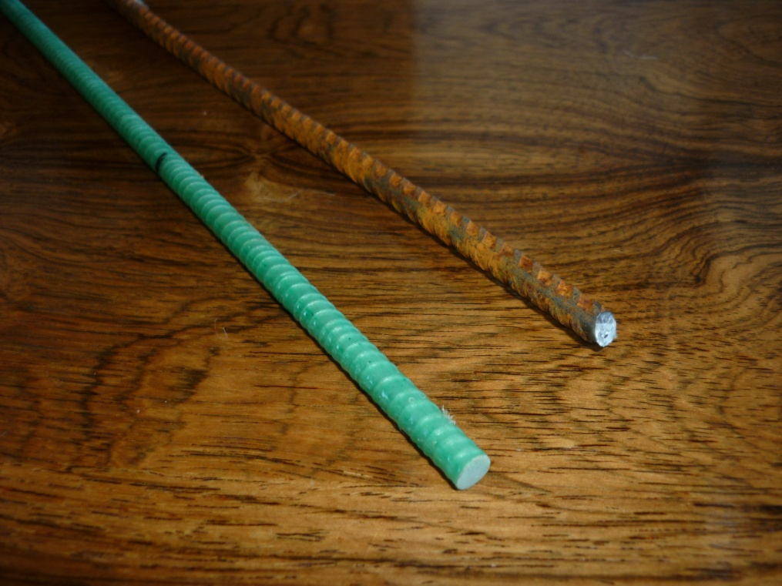

Steel

FRP

Figure 1 – Steel and FRP rebar.

The concrete used for the manufacture of the beams and cubes was a C50 characteristic design strength at 28 days, with a 60 mm slump. The high strength concrete will encourage a good bond between the rebar and the concrete. The actual mean value of the cubes tested for compressive strength was 58 N/mm² with a standard deviation of 4.2. The area of reinforcement used in the beams was 0.282% of the overall beam cross sectional area and this falls within the 0.21% - 4% of normal Eurocode design tolerances (Mosley 2007:131).

- METHODOLOGY

The two rebar types were tested using a single embedded bar in 150 mm cubes for bond strength. Flexural strength and toughness were tested using 100 mm x 100 mm x 500 mm beams. The concrete was subject to a compressive strength test using a Denison testing apparatus to BS EN 12390-3:2002 to determine the consistency between the batches. The bond strength, and flexural strength tests, used a calibrated LR100K Lloyd testing apparatus, using different set up methods specific to each test, which were bespoke tests designed for the purpose of this investigation.

A three point loading beam test was used to determine the flexural strength of the concrete beams embedded with steel and FRP composite rebar as shown in Figure 2. The Lloyds apparatus produced a controlled and constant increase of deflection and pull out of the specimen. The cross head speed used to provide the applied load rate for the pull out and three point beam tests was 0.1 mm/m and this was informed by ASTM 1018.

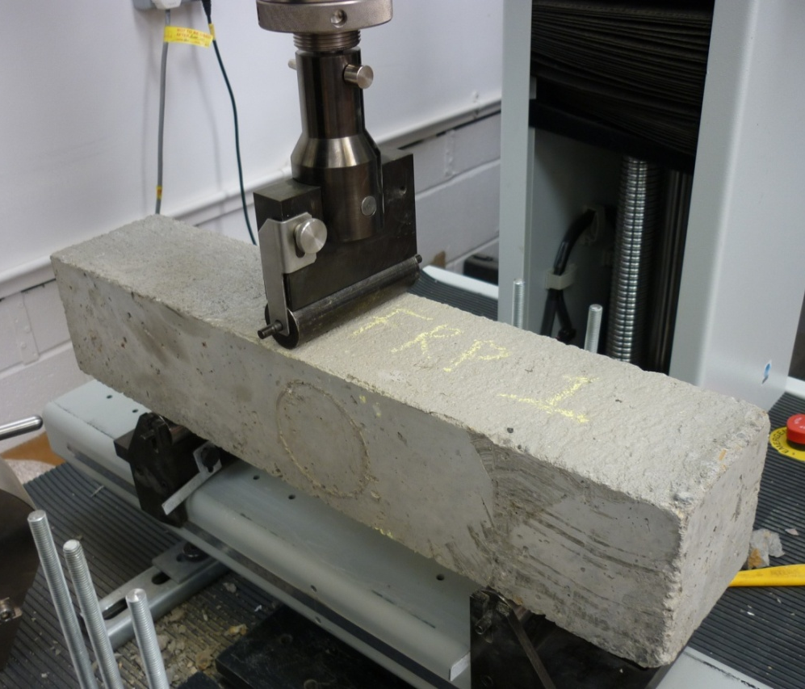

Figure 2 – Three point loading of beams

Load and deflection were recorded and residual strength, toughness indices, and first crack flexural strength were determined.

Golpalaratham and Gettu (1995:243) state, “most (toughness) standards are comparable, as ACI 544 uses a ratio of load/deflection curve so does ASTM 1018, which is essentially the same. According to Nataraja, et al (2000), the most common method to measure toughness, is to use the load-deflection curve. The test described herein used first crack (Serviceability limit state SLS) and final rebar failure load (ultimate limit state – ULS) and extension to show the ultimate point of failure as shown in Figure 3 and all extension/deflection readings were taken centrally off the beam.

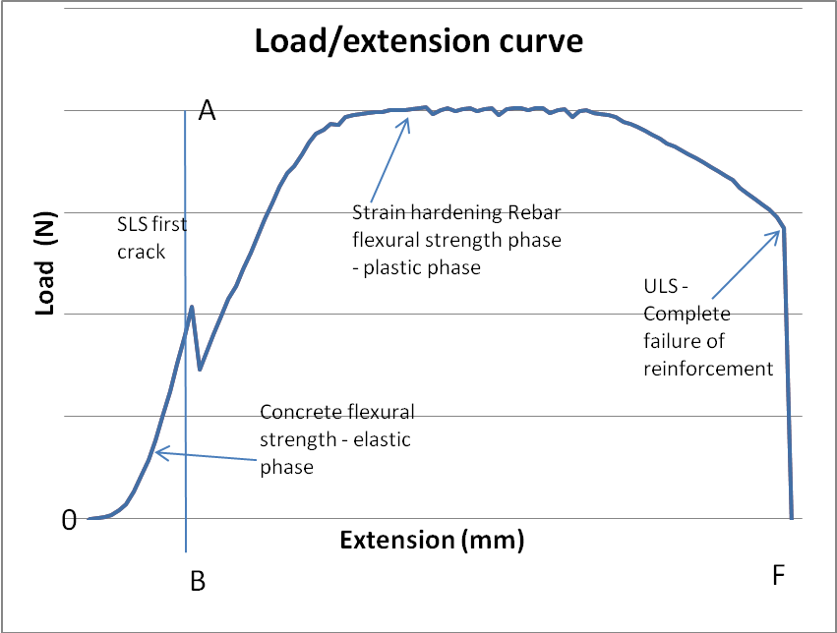

Figure 3 – Load and extnsion chart for both steel and FRP beams.
0

The area up to the first crack (OAB) was divided into the total area under the curve to determine the toughness indices between O and F. The beam was loaded until complete failure of the rebar occurred.

- Results
The cube specimens were tested individually for bond strength, each clamped down securely as shown in Figure 4 using four 10 mm diameter high tensile steel screwed anchor rods.

None of the embedded rebar failed by pull out. All failure modes were by tensile failure of the rebar. This indicates the pull out values as calculated in section 1.3 were too low and conversely a significant bond was achieved from both rebar types. This was a key aspect of this research to determine the bond performance of FRP rebar. The ambient temperature at the time of testing was between 18 to 20°C which did not affect the results.

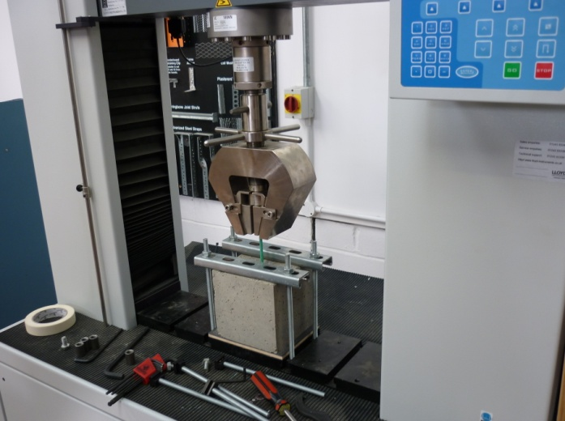

Figure 4 – FRP and concrete cube under tensile load

Table 1 shows the maximum load (kN) each specimen withstood before failure and the extension (mm) of the bar at this point. Comparison of the mean loads identifies the FRP specimens as being able to withstand a greater maximum load. The standard deviation for both sample populations were similar identifying an equal scatter within the results.

Specimen | Maximum load (kN) | Extension at maximum load (mm)
Steel 1 | 13.825 | 5.7928
Steel 2 | 18.496 | 6.5576
Steel 3 | 13.658 | 6.2103
Steel 4 | 15.729 | 6.4851
Steel 5 | 16.922 | 6.3291
Steel 6 | 18.442 | 7.0237
Mean | 16.18 | 6.399
Standard deviation | 2.15
FRP 1 | 18.214 | 6.449
FRP 2 | 18.926 | 5.8012
FRP 3 | 21.928 | 7.0636
FRP 4 | 19.018 | 5.8431
FRP 5 (outlier) | 5.4317 | 3.6887
FRP 6 | 24.051 | 10.269
Mean | 20.43 | 7.08518
Standard Deviation | 2.48

Table 1 - Bond strength test specimens - load & extension

Due to rebar clamping problems a lower value result was recorded for the FRP 5 bar and this outlier was removed from the analysis.

Table 2 shows the mean load percentage difference between the two specimens and extension per kN for each specimen type. The FRP bar withstood 26% more load than the steel specimen, however steel extended 14% more per kN than FRP. Indicating, FRP to be the stronger material in terms of withstanding load and extension forces. This result was not expected as the FRP has a lower modulus than steel, as identified by Kisicek, et al.(2009:1).

Specimen Type | Mean load (kN) | Mean extension at maximum load (mm) | Mean mm of extension per kN
Steel | 16.179 | 6.3990 | 0.396
FRP | 20.427 | 7.0852 | 0.347
Difference | 26% load | 14% extension per kN

Table 2 – Bond strength test specimens mean results & comparison

Testing of 14 beams in flexure using a three point loading frame was carried out for each reinforcement type and the flexural strength was calculated in accordance with BS EN 12390– 5:2000 as shown in Table 3 which highlights the superior performance of the FRP rebar.

 | Mean flexural strength at ULS (Failure) (N/mm²) | Mean flexural strength at SLS (First crack) (N/mm²)
FRP | 12.38 | 6.05
Steel | 8.95 | 4.84
Difference | 28% | 20%

Table 3 - Mean Flexural Strength at ULS and SLS

Figures 5 and 6 show typical load/extension charts obtained during the beam tests, both bars exhibited strain hardening properties.

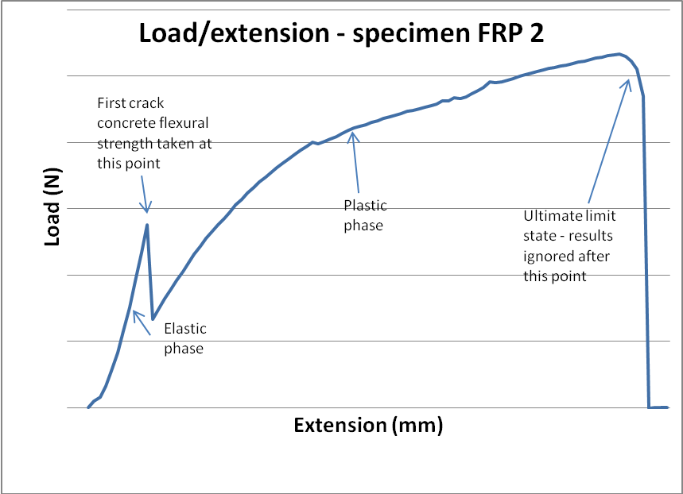

Figure 5 - Typical FRP load/extension relationship

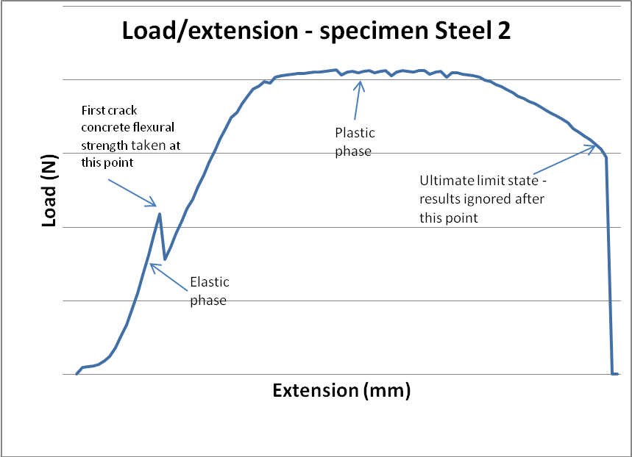

Figure 6 - Typical Steel load/extension relationship

All of the load extension charts produced had a 500 N preload which was taken into account for the purposes of the toughness indices calculations.

The typical failure mode of the FRP rebar is shown in Figure 7, this is a completely different failure when compared to the cup and cone failure observed in the steel rebar. The distance between the compression face of the beam and the centre of the rebar (d) was 75 mm in all cases.
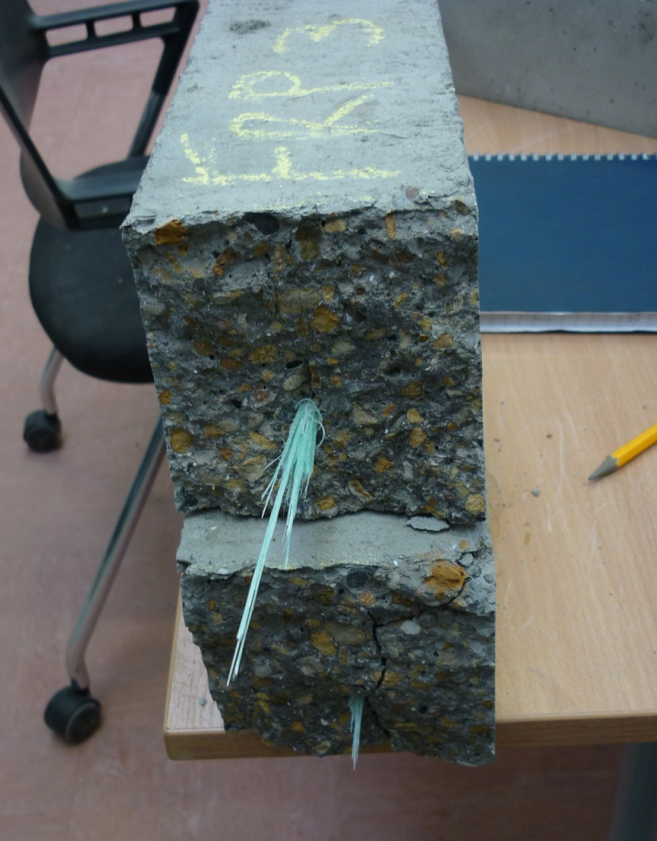

Figure 7 – FRP rebar failure.

All fracture planes occurred centrally under the point of load. Failure of the concrete was mainly due to the aggregate and cement shear and to a lesser degree aggregate pull out failure across the fracture plain. Very little evidence of compressive failure to the top of the beam was observed. FRP produced a more progressive failure than steel and the bond between the rebar and the concrete remained intact on either side of the fracture plane. This was observed by breaking the beams apart to expose the rebar after ULS failure had occurred and measuring any slippage.

Table 4 shows the toughness indices values as defined in Section 3 for each test specimen, with their mean values and standard deviation.
Specimen | Toughness indices | Specimen | Toughness indices
Steel 1 | 38.34 | FRP 1 | 24.7
Steel 2 | 37.39 | FRP 2 | 46.06
Steel 3 | 24.24 | FRP 3 | 49.95
Steel 4 | 33.88 | FRP 4 | 27.27
Steel 5 | 26.41 | FRP 5 | 35.86
Steel 6 | 18.22 | FRP 6 | 74.55
Steel 7 | 19.48 | FRP 7 | 71.79
Steel 8 | 23.45 | FRP 8 | 35.22
Steel 9 | 26.41 | FRP 9 | 37.11
Steel 10 | 28.2 | FRP 10 | 48.15
Steel 11 | 24.19 | FRP 11 | 66.56
Steel 12 | 37.65 | FRP 12 | 52.23
Steel 13 | 29.28 | FRP 13 | 50.87
Steel 14 | 22.65 | FRP 14 | 50.79
Mean | 27.25 | Mean | 47.93
Standard Deviation | 6.81 | Standard Deviation | 15.34

Table 4 - Toughness indices tables for steel and FRP rebar

A parametric “T” test was performed at 95% confidence to compare the variation between the mean values of the two beam types. The null hypothesis for this test is that there will be no difference between the toughness indices of a steel reinforced beam to the beams with FRP reinforcement bar. The null hypothesis was rejected. We can therefore conclude the performance between the steel and FRP rebar was significant

- Conclusion

The purpose of this research was to investigate whether FRP rebar has the required properties to be used as primary reinforcement within concrete structures, by testing and comparing the FRP rebar to a steel specimen of the same length and nominal diameter.

Bond strength testing of the two rebar types was a success as both types of rebar failed before bond strength was compromised given the embedded depth of bar was the same for both types of rebar. Both bars exceeded their expected bond performance and this was confirmed exposing the rebar following the beam test.

The flexural strength test showed a beam with FRP reinforcement withstands higher loads at SLS or first crack as well as ULS. The FRP beams also has a more desirable failure mode at ULS, with the beam not only breaking at a higher load than that of steel, but gradually breaking apart rather than an instant snapping of the rebar. As the steel beam results were more consistent, further FRP testing is recommended to ensure the results would be equally as consistent as the steel.

FRP rebar is about 2 ½ times the cost as steel, however in comparison with steel with corrosion prevention coating or stainless steel, FRP can sometimes be cheaper.

- Further work

Four areas of recommended further research are proposed,
- Initial cost investigation of FRP product to its whole lifecycle cost with regards to durability.
- Research the potential of FRP as reinforcement within seismic (earthquake) zones
- Develop hybrid beams with high toughness values using short Type 2 structural fibres of the same material as the vinyl ester rebar.
- Use larger diameter rebar, as small rebar is easier to manufacture and performs at higher stress values than bar with a greater cross sectional area.
- Test the structural efficacy of bent FRP bars and examine the production of angled FRP bars where on site variations are required.

7.0 Acknowledgement
Thanks to Marc Schurch for supplying the FRP rebar which has been in production since 2004. Item iv) above was informed following discussions with the FRP manufacturers technical advisors (FiRep). Thanks also to Steve Colvin (laboratory manager at Northumbria) for overseeing the testing and operational procedures.

8.0 Referenced work
Allen. E., & Iano. J., (2009), Fundamentals of Building Construction – Materials and Methods, 5th ed., John Wiley and Sons, Inc.: Hoboken, New Jersey

Bakis C E, Uppuluri V S, Nanni A & Boothby T E, (1998), “Analysis of Bonding Mechanisms of Smooth and Lugged Fibre Reinforced Plastic Rods Embedded in Concrete”, Composites Science and Technology, Vol 58, Elsevier Science Ltd, GB, pp 1307 1319.

Cadei. J. M. C., Stratford. T. J., Hollaway. L. C. & Duckett. W. G., (2004), Strengthening metallic structures using externally bonded fibre-reinforced polymers, CIRIA: London

CIRIA (1995), Steel Reinforcement, Special Publication, CIRIA: London

Clarke J, (2010), email communication, The Concrete Society, Riverside House, 4 Meadows Business Park, Station Approach, Blackwater, Camberley, Surrey GU17 9AB

Cripps. A., (2002) Fibre – reinforced polymers composites in construction, CIRIA, MWL: Pontypool, South Wales

Golpalaratham. V. S. & Gettu. R., (1995), “On the Characteristics of flexural toughness in fibre reinforced concrete”, Cement and Concrete Composites, Vol 17, (1995), pp 39 – 254.

Harik. I. & Peiris. A., (2009), Twelve years of field applications of FRP materials in Kentucky, FRPRCS-09: Sydney
Kisicek. T., Soric. Z. & Galic. J., (2009), Stress and strain distribution in concrete beams reinforced with FRP bars, FRPRCS-09: Sydney

Masmoudi. R., Masmoudi. A., Benouezdou. M. & Daoud. A., (2009), Thermal effects on bond properties of GRFP rebar embedded in concrete: experimental study and analytical interpretation, FRPRCS-09: Sydney

Mathieu R, and Brahim B, (2009), Characterisation and Lond Term Durability of GFRP Reinforcing Bars Embeded in Moist Concrete, FRPRCS-09: Sydney

Metha. M., Scarbororough. W., & Armpriest. D., (2009) Building Construction - Principles, Materials and Systems, 2009 building code and sustainability update, Prentice Hall: New Jersey

Mosley B, Bunget J and Hulse R,. (2007), Reinforced Concrete Design to Eurocode 2, 6th Edition, Palgrave Macmillan, UK

Nataraja. M. C., Dhang. N. & Gupta. A. P., (2000), “Toughness Characteristics of steel fibre-reinforced concrete by JSCE approach”, Cement and Concrete Research, Vol 30, pp593 – 597

Pilakoutas. K., Guadagninni. M., Neocleous. K. & Matthys. S., (2009), The FIB perspective on FRP reinforcement in RC, FRPRCS-09: Sydney

Tharmarajah. G., (2009), Compressive membrane action in FRP reinforced slabs, FRPRCS-09: Sydney

Zhang. Y. X. & Zhu. Y., (2009), Nonlinear numerical modelling of FRP-Reinforced concrete slabs, FRPRCS-09: Sydney

